UNIT 1 & 2 NOTES

ATOMIC STRUCTURE
The History of Atomic Structure
Bohr Model of Atom: Electrons, Flame Tests and AAS
_Bohr Model: electrons travel in orbits, or energy levels, around the nucleus. The further the electron is from the nucleus; the more energy it has.

_Electromagnetic Spectrum: the classification of electromagnetic waves according to their frequency.
_Photons: particles of light energy. Each wavelength of light has photons that have a different amount of energy. The longer the wavelength, the lower the energy of the photons.
A photon of blue light
A photon of red light
Why an element’s line spectrum can be used to identify it?
- When atoms are energized, their ‘excited’ electrons jump to a higher energy level. Because of the instability, the electrons will jump back down to its ground state by releasing the excess energy in the form of light. The wavelengths of the emitted light depend on the difference in energy between the ground state and the excited state. An element has its unique amount of energy in each energy level, so it only emits specific wavelengths and light color.

_Flame Test: an analytical technique that relies on an element’s unique emission spectrum to identify its presence in a mixture of compound, often used for metal ions.
- A small sample of unknown compound is placed in a hot Bunsen burner flame.
- Sample vaporizes and the heat of flame excites electrons.
- Electrons return to ground state, emitting light with wavelength characteristic of element.
_Limitations: only used for small number of metal ions due to limited source of energy in the flame; unclear results, which can be fixed by using a spectroscope to see line emission spectrum of a flame.
Metal Ions | Flame Color
Boron | Bright Green
Barium | Pale Green
Calcium | Red/ Orange
Copper | Blue/ Green
Iron | Gold
Lithium | Red/ Crimson
Potassium | Violet/ Lilac
Strontium | Deep Red
Sodium | Yellow
Atomic Absorption Spectroscopy – both quantitative and qualitative
- Use lamp containing the same element (gaseous state) as the one being tested and emits identical wavelengths of light to be absorbed.
- Sample is vaporized by the flame and atoms are separated so they can absorb light from the hollow cathode lamp. Only atoms of the element that we are looking for will absorb the emitted wavelengths from the HCL.
- Light passes through a monochromator, which is set to select specific wavelength for analysis by detector.
- Detector measures the amount of light remaining without being absorbed = absorbance value, which tells us the quantity of the element being tested.

Classifying of Matter

Homogeneous |  |  | Heterogeneous
Pure substance |  | Mixture
- Particles making up a substance are all of the same kind  - Materials with distinct measurable properties (MP, BP, reactivity, strength and density) |  | - Contain two or more different kinds of substances  - Can be composed of elements or compounds or both, which can be separated out by physical properties  - Material properties dependent on the identity and relative amounts of the substances that make up the mixture
Element | Compound | Solution  Ex. Air, sugar dissolved in water solution and glass | Mixture that is not a solution  Ex. Nuts mixture or cement
Cannot be decomposed by chemical reactions, either metal or non-metal | Made from two or more elements chemically combined

Physical Properties | Chemical Properties
Can be found by studying the substance itself rather than its chemical reactions | Describe how it reacts chemically and its tendency to form new substances
Ex. Solubility, state, MP, BP and conductivity | Ex. Reactivity, ability to be stable or decompose with heat and acidity

Separation of Mixture
Separation Method | Magnetic | Electrostatic | Sieving | Filtration
Procedure | Remove magnetic materials from a mixture using a magnet | Separate materials that have different charge | Used for mixture of solids or solid a liquid  Unlikely to produce pure substance | Separated insoluble solids from a liquid or gas
Physical Properties | magnetism | Electrical charge | Particle size | Particle size and solubility

Decantation | Centrifugation | Separating Funnel | Gravity Separation | Evaporation
Separate solids from a liquid by pouring off the liquid to leave the solid behind | A mixture is spun in a machine called centrifuge. The high speed causes less dense substance to rise to the top | Separates immiscible liquids, which form 2 layers due to difference in density | Heavier particles fall to the bottom when the container is shaken | Heat causes a liquid to turn into a gas, leaving behind any solids that were dissolved in the liquid, as well as impurities
Density | Density | Density and solubility | Force of gravity | Boiling points

Crystallization | (Fractional) Distillation | Chromatography
Purify impure solid substance  - Dissolve both solid and impurities in solvent at high temperature. Hot filtration to remove any solid impurity  - Cool to room temp. Desired solid is less soluble at room temp, so it will crystallize  - Crystals are filtered out of solution, washed with cold solvent and dried. | Separate a solid from a liquid or a mixture of liquids.  - Solution is boiled, solvent changes to vapor.  - Vapor passes down a condenser, where it is cooled and converted back to liquid.  - The liquid is collected as the distillate in the flask.
Solubility | Boiling point | Intermolecular Forces

Chemical Bonding
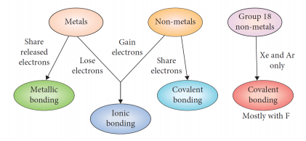
 | Giant Lattice |  |  | Molecular
 | Metallic | Ionic | Covalent Network | Molecular Covalent
Components | Metals | Metals and Non-metals | Group IV Non-metals | Non-metals
Examples | Cu, Fe | NaCl, CaO | SiO₂, C₆₀ | CO₂, H₂O, Cl₂
Type of individual particles | Positive ions surrounded by negative delocalized electrons | Positive and negative ions | Atoms | Small individual molecules
Bonding Force | Strong electrostatic attraction | Strong electrostatic attraction | Strong covalent bonding due to strong electronegativity | Electronegativity  Strong intramolecular covalent bonding  Weak intermolecular forces
Directional Bonding
Delocalized Electrons |  |  | Except for graphite
Model | Mobile sea of electrons | Ionic lattice | Continuous array (diamond)  Graphene (graphite)  Soccer ball shape (fullerenes) | Clusters of molecules
Lewis Dot Diagram |  | 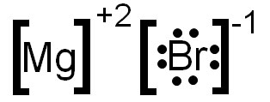 |  | 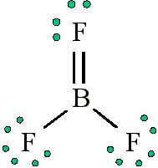

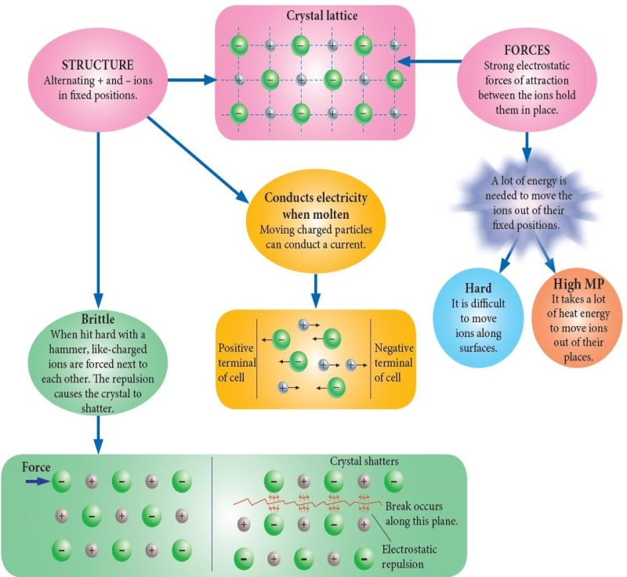

Ions with a transition metal = colored
Ions with an alkaline/ alkaline earth metal = white

Properties of Types of Bonding
Properties | Metallic | Ionic | Covalent
 |  |  | Molecular | Network
Metallic characteristic (reactivity/ tendency to lose electrons) | Very high | Moderate | Low | Low
M.P & B.P | High  - Strong electrostatic attraction  - The more valence electrons, the higher MP and BP | High  - Strong electrostatic attraction between cations and anions | Low  - Weak inter. Forces | Very High  - Strong intra. Molecular covalent bonding lattice
Hardness | Generally hard  - Strong bonding  - Close packing ions | Hard  - Strong bonding | Soft  - Weak inter. Forces | Very hard  - Strong lattice (except for graphite)
Brittleness | Not brittle  - Non- directional bonding so electrons can slide over ions | Very brittle  - Directional bonding, shifted ions cause like charged ions to repel | Soft | Brittle  - Directional bonding, once disrupted the lattice is brittle
Malleability (hammered into sheets) & ductility (drawn into wires) | Malleable & ductile  - Flexible delocalized electrons | None, brittle | None, soft | None, brittle
Solubility in water | Insoluble | Soluble  - Ion-dipole forces pull ions from its lattice | Insoluble  - No attraction between water and the molecules | Insoluble
Electrical conductivity | Good  - Delocalized electrons | Only conductive in liquid and aqueous phases  - Charged ions | Insulator  - Localized electrons | Insulator  (except for graphite)
Thermal conductivity | Good  - Delocalized electrons and vibration of ions | Quite good  - Vibrations of ions, but slow | Poor | Poor  (except for graphite)

Allotropes of Carbon
Allotropes:
- different forms of the same element;
- have similar chemical properties;
- but different physical properties due to different arrangement/ structure.
Structure
Diamond | Fullerenes | Graphite | Carbon nanotubes
- Rigid 3-D tetrahedral structure  - Each atom is covalently bonded to 4 other atoms  - No free electrons  - Very strong covalent bonding | - 60⁺ carbon atoms  - Arranged in a sphere or cage  - Each atom is bonded to 3 other atoms  - 1 delocalized electron/ atom  - Weak inter. forces  - Strong intra. forces | - Layers of 2-D hexagonal shaped rings.  - 6 rings (graphene)/ layer  - Each atom is bonded to 3 other atoms  - 1 delocalized electron/ atom  - Weak inter.  - Strong intra. | - Walls made of 1 single layer of graphite rolled into a cylinder shape  - Each atom is bonded to 3 other atoms  - 1 delocalized electron/ atom  - $1^{+}dimension=1nm=1×{10}^{-9}m$
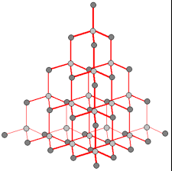 | 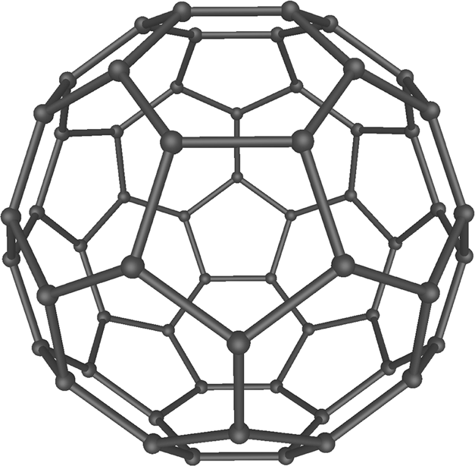 | 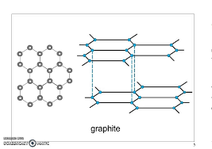 | 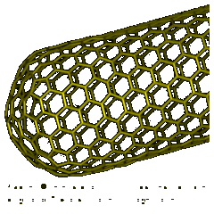

Conductor of heat & electricity
Poor  - No mobile electrons | Semi  - Delocalized electrons can’t move between molecules | Good  - Delocalized electrons can move between graphene sheets | Good
Hard/ soft & brittle
Hard & brittle  - Continuous, strong array | Hard & brittle | Soft & tensile strength  - Graphene sheets can slip over each other  - Strong intra. | Same as graphite
BP & MP
High | High | High | High

Chemistry Calculations
Relative Atomic Mass Ar: mass of an atom compared with one-twelfth of the mass of an atom of carbon-1.
$$A_{r}=\frac{\%a×{Ar}_{a}+\%b×{Ar}_{b}}{100}$$
Relative Molecular Mass Mr: mass of a molecule compared with one-twelfth of the mass of an atom of carbon-12.
$$A_{r}=sum of Ar of the component atoms$$

$$Percentage composition=\frac{mass of a component}{mass of the total formula}×100$$

Energy Changes in Chemical Systems
- Enthalpy/ Heat content (H): sum of potential and kinetic energy of a substance.
- Change in enthalpy: smaller in physical changes than chemical reactions

$$ΔH= H \left(products\right)– H \left(reactants\right) J{mol}^{-1}/kJ{mol}^{-1}$$
Exothermic Reactions | Endothermic Reactions
Release energy and heat up surroundings | Absorb energy and cools the surrounding down
Negative ΔH: Enthalpy of product is reduced | PositiveΔH: Enthalpy of product is increased
Energy Profile Diagram  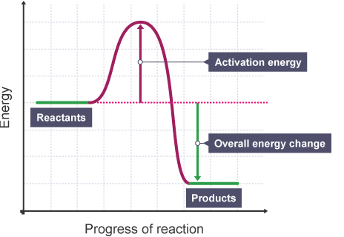 | Energy Profile Diagram  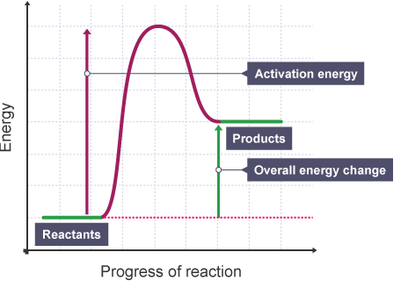
2H2 (g) + O2 (g) 2H2O (l) ∆ H = -572 kJ  2H2 (g) + O2 (g) 2H2O (l) + 572 kJ | CO2 (g) C (s) + O2 (g) ∆ H = +394 kJ  CO2 (g) + 394 kJ C (s) + O2 (g)

Biofuels
- Biofuels: fuels made from organic materials & are considered “renewable”.
Biofuel | Bioethanol | Biodiesel
How it’s made | Produced by fermentation of starchy crops (sugar cane, corn, wheat) | Made by processing feedstock: vegetable oil, soybean oil, animal fats.
Advantages | Few modifications are needed  Carbon neutral, biodegradable and non-toxic  Suited to both small-scale home production or large scale industrial
Disadvantages | Carbon dioxide is still produced due to transportation of feedstock, biofuel production and distribution using fossil fuels  Deforestation to plant feedstock for resources

Organic Compounds
- An organic compound: made from carbon atoms.
- Structure & Properties:
  - covalent bonds
  - low MP & BP
  - flammable
  - soluble in non-polar solvents
  - insoluble in water
- Hydrocarbons: organic compounds containing only carbon and hydrogen bonded covalently.
- 4 classes of hydrocarbons: alkanes-saturated, alkenes, alkynes &aromatic compounds (benzene) –unsaturated.
- Alkanes: CnH2n+2
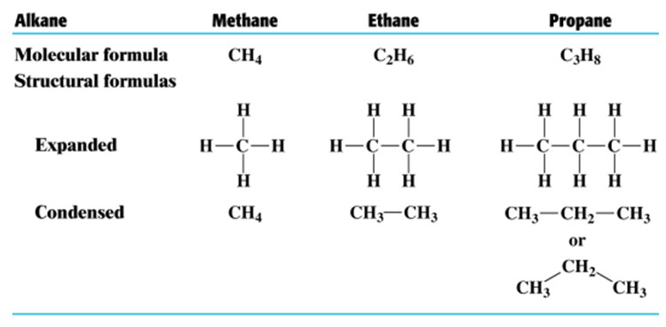

- Enprirical formula: ratio between C and H
Ex. C₄H₁₀ = C₂H₅
- Naming:
  - prefix: meth-, eth-, prop-, but-, pent-, hex-, hept-, oct-, non-, dec-
  - suffix: -ane
- State:
- 1 – 4 carbon atoms: gas
- 5 – 8 carbon atoms: liquid
- 9 – 17 carbon atoms: thick liquid
- 18⁺: solid
- Alkenes: CnH2n
- Isomers: same molecular formula but different atom arrangements; similar chemical properties and different physical properties.

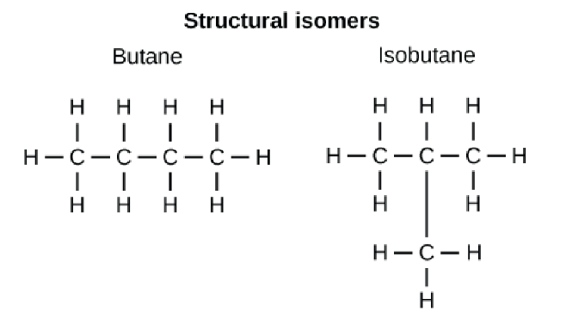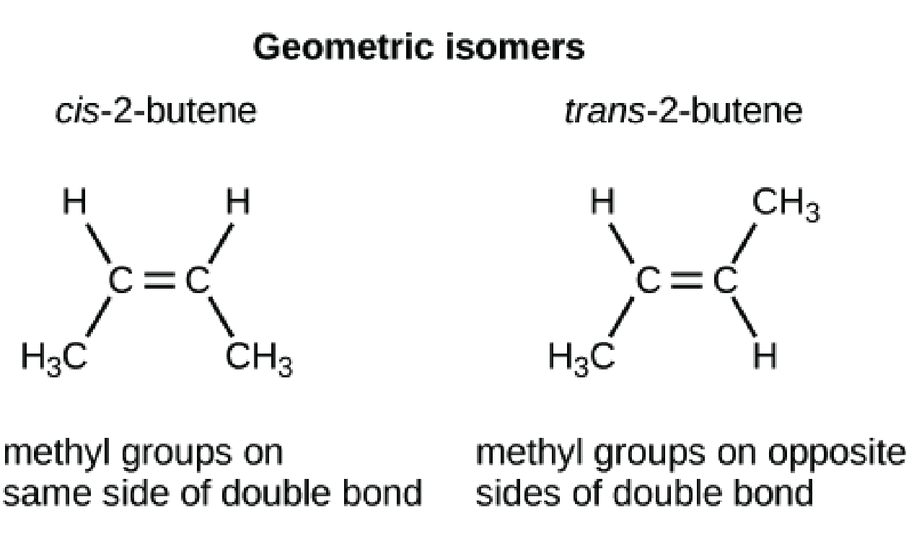
- Alkynes: C_{n}H_{2n-2}
- Benzene: C₆H₆
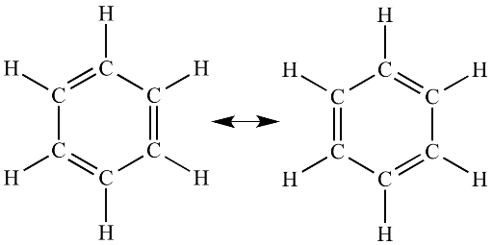
  - Structure: Stable, flat hexagonal rings; Identical bonds, which are intermediate in length; C atoms have double bonds to either of its neighboring C atom.

Some benzene molecules can be carcinogen.

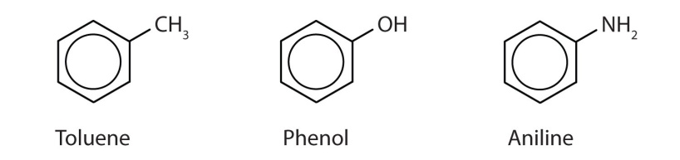
- Aromatic: Benzene based compounds but one or more H atoms are replaced with other halides/ halogens or alkyl groups.
Ex. 1-bromo- 3- cloro- 5- methyl benzene
- Cyclic Hydrocarbons: alkanes, alkenes or alkynes that are arranged in rings; have 2 less hydrogen atoms than non – clyclic forms; prefix: cyclo-
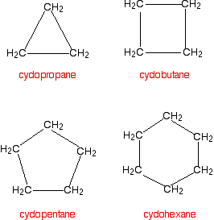
- IUPAC nomenclature for hydrocarbons:
- Stem name is equivalent to the longest chain that contains the double/ triple bond.
- Principal functional groups have to obtain the lowest number.
Priorities: double/ triple bond, halogens (F, Cl, Br, I), alkyl groups (methyl, ethyl, …)
- Prefixes determined by the principal functional group.
- Use 1 word to name the compound:
Name of each group is started with a number indicating its position.
Alphabetical order is applied when listing the groups.
Di, tri, tetra,… do not affect the order.
- Hyphen seperates numbers and words.
Comma seperates numbers.
- Number attached group from #2.

Rections of Hydrocarbons
- Addition Reactions:
- Occur with alkene or alkynes (unsaturated reactants).
- Faster than substitution.
- Reagents: H_{2(g)}, Cl_{2(aq)} – clorine water, Br_{2(aq)} – bromine water, HCl, HBr, HI.
- Observations: Yellow Cl₂ water quickly turns colourless/ Red-brown Br₂ water quickly turns colourless.
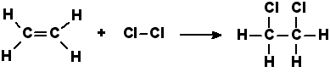
- Substitution Reactions:
- Occur with saturated hydrocarbons (alkanes, benzene and aromatics).
- Reagents: clorine water, bromine water, catalyzed by UV, Pt, Ni and/or heat.
- Slower than addition, which is why it is used to distinguish between saturated and unsaturated compounds.
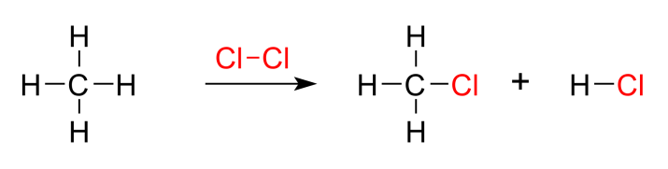
- Combustion Reactions:
- Products: CO_{2(g)} & H₂O_{(g)} & energy (complete combustion)/ CO_{(g)}/ C_{(s)} soot + H₂O_{(g)} & less energy (incomplete combustion).
Ex. Complete combustion: 2C₄H_{10(g)} + 13O_{2(g)} 8CO_{2(g)} +10H₂O_{(g)} + 5754 kJ
Incomplete combustion: 2C₄H_{10(g)} + 9O_{2(g)} 8CO_{(g)} +10H₂O_{(g)} + 3490 kJ
Rates of Reaction
- Rate of reaction: rate at which reactants are used up or the rate at which products are formed; measured in mol s⁻¹, gs⁻¹ or mL s⁻¹.
- Collision Theory: conditions for reactions to occur:
- Individual particles of the reacting substances must collide.
- The collision energy must be equal to or greater than activation energy, E_{a}.
- The reacting particles must collide with a suitable orientation.
- Increased chance of collisions, increased rate of reaction.

- Factors of ROR:
- Nature of reactants: ionic reactions are faster than molecular ones because they have less bonds to be broken and formed as the ions are held together by electrostatic forces of attraction.
- Conc. of reactants: proportional relationship
- State of subdivision of reactants: more surface area, faster ROR.
- Temperature:
- Higher kinetic energy, faster velocity and therefore more collisions.
- More particles have sufficient activation energy, so more reactions can occur.
- Gas pressure: decreased volume or adding more gas particles increase the pressure, only applied to gas as liquid and solid usually can not be compressed.
- Catalyst: not consumed in a reaction but provide an alternative easier pathway by lowering the E_{a}.

- Activation Energy: energy that colliding particles must have to form an activated complex.
- Transition state: very unstable point of the reaction where bonds are breaking and forming.
- Energy Profile Diagram:
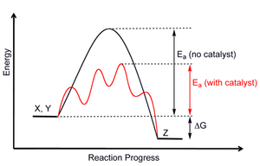
Transition State with Activated Complex

- Examples of catalysts:
- Enzymes: not consumed, highly specific, lock &key model, specific temperature and pH.
- Transition metals and their compounds: Pt, Pd, Au, MnO₂ & Rh.
- Nanoparticles: at least one dimension is 1 – 100nm, have a large surface area.
- Catalytic converters: reduce toxic gases using platinum, Rhodium, palladium with high SA, increased ROR of CO & unburnt fuel with oxygen, so only carbon doixide and water are produced; convert NO to N₂ and O₂.
VSPER Theory & Polarity
- Valence Shell Electron Pair Repulsion theory states that:
- Pairs of outer shell electrons in atoms form charged clouds which are roughly spherical in shape.
- These charged clouds repel each other and so are positioned as far apart as possible. This includes both bonding and non-bonding pairs of electrons.
- However, lone pairs have larger repulsive forces.
Shape | Linear | Triangular Planar | Tetrahedral (trigonal planar) | Pyramidal | Bent (V-shaped)
Bond Angle | 180° | 120° | 109° | 107° | 104.5°
No. bond pairs | 2 | 3 | 4 | 4 | 4
No. lone pairs | - | - | - | 1 | 2
Shape diagram | 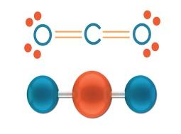 | 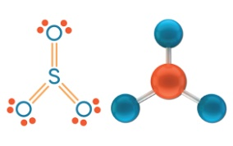 | 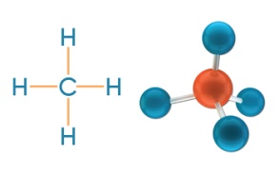 | 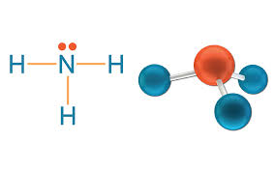 | 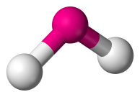

- Electronegativity:
- Attraction of an atom for shared electrons
- Increases from left to right
- Highest: flourine, lowest: lithium.
- Non-polar covalent bonds: only between non-metals, EN dif.= 0 to 0.4
- Polar covalent bonds: only between non-metals, EN dif.= 0.5 to 1.7
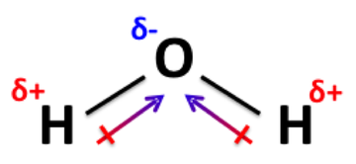
- Ionic bonds: between metals and non-metals, electrons are transferred, and EN dif.= 1.8⁺

- Polar dipoles: exist in polar bonds/ molecules, negative end attracts more electrons.
Intermolecular Forces
- Dispersion Forces:
- Weakest intermolecular forces
- Exist between all molecules
- Temporary instantaneous dipoles
- Increases with increased molecular mass and in linear shaped molecules.
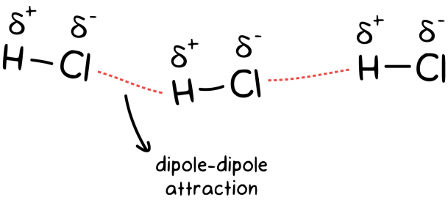
- Dipole-dipole Forces:
- Weak but permanent
- Between polar molecules only

- Hydrogen Bonding Forces:
- Strongest
- Between poalr molecules
- Between the hydrogen atom of a O-H, N-H or F-H bond to the N, O or F atom of another molecule, which has a lone pair that attracts hyfrogen atoms.
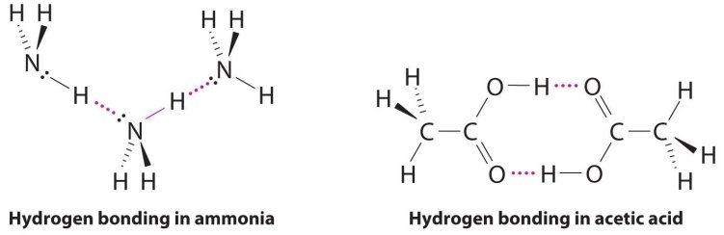
Generally, network covalent > metallic > ionic > hydrogen bonding forces > dipole-dipole forces > disperson
Use intermolecular forces to compare & explain physical properties of covalent molecules
- M.P & B.P: increase with increased strength of intermolecular forces
- Vapour Pressure: tendency of a substance to evaporate, measured in kPa, Pa or atm; increases with decreased intermolecular forces; when vapour pressure = atmospheric pressure => liquid boils.
- Solubility: when a new solution is formed, the new solute – solvent interactions are equal or stronger in strength, so covalent network is insoluble due to the strong intramolecular forces; “like dissolves like”.
Chromatography: paper chromatography, TLC, GC & HPLC
- Mechanism:
- Stationary phase: solid or liquid supported in a solid (paper)
- Mobile phase: liquid or a gas (water)
- If components move quickly = high retention factor => they are strongly attracted to the mobile phase
- If components move slowly = low retention factor => they have strong interactions onto the stationary phase.
$$Retention Factor R_{f}=\frac{distance of component}{distance of solvent} both from the pencil line$$
- Paper chromatography:
- Stationary phase : polar paper (dipole dipole forces and water)
- Mobile phase: polar water (all intermolecular forces)
- Thin Layer Chromatography:
- Stationary phase: thin layer of silica gel SiO₂, cellulose, starch or alumina Al₂O₃ coated on a sheet of metal, plastic or glass.
- Mobile phase: non – polar liquid solvent or water
- Advantages: simple, rapid, inexpensive; small amount of test substance; non – destructive, only involves physical seperation.
- Gas Chromatography:
- Sample is vaporised into gas molecules
- Stationary phase (coiled to increase SA): solid – gas chromatography (solid absorbant)
liquid – gas chromatography (liquid on an inert support)
- Mobile phase (carrier gas): inert non-polar gas (He or N₂)
- Polar and/or large molecules stay longer
- Non – polar volatile components elute (pass through) faster.
- High Performance Liquid Chromatography
- Mobile phase is pushed through stationary phase under high pressure.
- Stationary phase: solid particles of silica or polymers tightly packed.
- Mobile phase: liquid solvent.
- Normal phase HPLC: polar S.P, non-polar M.P; vice versa.
- Advantages:
  - Can analyse compounds that decompose in gas chrom.
  - Faster due to high pressure
  - Small particles of adsorbent material on stationary phase create a large SA.
Properties of Gases and Kinetic Theory of Gases
Kinetic Theory Assumptions:
- Gases consist of tiny particles moving in rapid, random, straight-line motion until they collide with one another or with the container (Brownian motion).
- Collisions between particles or witht the walls are perfectly elastic.
- The size of the particles are negligible compared to the size of their container
- The particles have mass but no volume
- Distance between particles are larger than their size
- Any attractive/repulsive forces between particles are negligible
- Average kinetic energy increases as temperature increases

Therefore, gases can be compressed and diffuse.
Real Gases | Ideal Gases
Have volume | No volume
Particles attract and repel one another | No forces exist between the particles
At temperature and pressure close to phase changes, gase behavious is affected by intermolecular forces  Stronger intermolecular forces, less molar volume | Molar volume = 22.71 L/mol

Properties of gases
- Pressure (P): force exerted by gas against the walls of the container, increases as temp and velocity increase.
$$Pressure= \frac{Force }{Area}$$
- Units: atm, mm Hg, torr, pascal
1 atm = 760 mm Hg = 760 torr = 100 kPa

- Volume (V): space occupied by gas, measured in L or mL.
- Amount (n): quantities of gas particles, in grams or moles.
- Temperature: average kinetic energy of all molecules
$$E_{k}=\frac{1}{2}mv^{2}$$
Gas Laws
$$P_{1}V_{1}=P_{2}V_{2}$$

- Boyle’s Law - $P∝\frac{1}{V}$
$$\frac{V_{1}}{T_{1}}=\frac{V_{2}}{T_{2}}$$
- Charles Laws – V $∝$ T

- Gay – Lussac’s Law – P $∝$T
$$\frac{P_{1}}{T_{1}}=\frac{P_{2}}{T_{2}}$$

- Avogrado’s Hypothesis: at the same temp and pressure, equal volumes of gases contain the same amount of particles
$$\frac{V_{1}}{n_{1}}=\frac{V_{2}}{n_{2}}$$

- Molar Volume: volume of 1 mole, or 6.22 × 10²³ particles of gas.
- Standard molar volume: volume of 1 mole of ideal gas at STP, or at 0°C and 100kPa = 22.71 L/mol.
$n=\frac{V}{22.71}$ at STP

- Ideal Gas Equation: when conditions are not at STP
Pressure in kPa n in moles
$$PV=nRT$$
Volume in L Temperature in Kelvin

- Combined Gas Law
$$\frac{P_{1}V_{1}}{T_{1}}=\frac{P_{2}V_{2}}{T_{2}}$$

